Energy Transaction Management System
(ETMS)
Phase 1
FRONT OFFICE
Functional Design Specification & Users Guide

Contents
Contents 2
Sign-Off Page 4
Revision History 5
Document Conventions 5
Overview 6
Important Notes 6
Deal Entry 7
Deal Entry Workflow 7
Deal Entry Screen 8
Deal Entry Screen Buttons 9
Reference Panes 9
Parties Pane 9
Pane Components 9
Deal Entry Pane, Fields & Pop-Up Windows 11
Deal Entry Pane 11
Deal Entry Fields 12
Field Pop-Up Windows 14
New Trader Window 15
New Book Window 16
New Counter Party Window 17
Contract Admin Window 20
New Counter Trader Window 22
New Broker Window 23
Details Pane, Fields & Pop-Up Windows 25
Forward Trades 25
Details Pane 25
Field Descriptions 26
Swap Trades 29
Details Pane 29
Field Descriptions 30
Put & Call Option Trades 33
Details Pane 33
Field Descriptions 34
Dual-Option Trades 38
Details Pane 38
Field Descriptions 39
Confirm 42
Field Pop-Up Windows 43
New Delivery Location Window 44
New Pricing Point Window 45
New Product Shape Window 47
New Settlement Index Window 49
New Monthly Fixed Premium Schedule Window 51
New Volatility Curve Window 53
New Buy-Sell Correlation Window 55

Sign-Off Page
Name & Title | Signature | Date
IS Scientific Systems
Baruch Braug,
Technical Writer
Engineering & Ops Support, IT Supervisor
Engineering & Ops Support, Sr Apps Developer
WA Energy Services
Energy Analyst
Energy Services Manager
State of California Commission (SCC)
Systems Coordinator

Revision History
Date | Description
01/04/06 | Initial draft.
2/28/07 | Updates based on 2-14-07 meeting (per JW)
11/6/08 | Updates based on the new ETMS Engine paradigm and revised architecture

Document Conventions

Special Type Faces
Text in Arial Italics indicates references to named sections of this document where more detail can be found (these can be major ETMS components or other named sections). Text in Bold Aerial identifies ETMS components that don’t have named sections; such as a screen’s fields, tabs, pop-up windows, etc. Italicized text represents field values and user inputs.

Legends
BR: = Business Rule Annotation

Overview
This functional design specification describes the ETMS screens, panes (screen areas), fields and ETMS-centric workflows used by the Front Office to enter energy acquisition deals.
The ETMS components described in this document support the business processes defined by Front Office personnel and management during analysis and design review meetings.

Important Notes

Current Prototype Functionality & Appearance
All of the functionality and appearance described in this document has been released into “Beta” and currently in use for evaluation and Beta testing in parallel with legacy production workflow.
In addition, some of the screen shots in this document display “dummy” data— However, there is a Beta environment operating with live production data.

ETMS Functionality—Organization & Presentation
The ETMS is an enhanced and extended combination of two existing applications currently in use: Excel spreadsheet-based Position Manager and PHP Web-based eStar. Although the specified functionality of both of these applications are being incorporated into the new ETMS, functions may be organized and presented in the new UI to users in ways that differ from the original applications.

Changes to This Design Specification
It should be understood that the functionality and appearance of the ETMS described in this document may change as the system is developed, due to either customer requests or technological limitations. This is a “living document” and it will be updated periodically to reflect these changes.

ETMS Menu

The ETMS Main Menu is launched from a browser using the URL supplied below:
http://etms.sample.com
The customers in the Energy Group are required to use Firefox when launching ETMS.

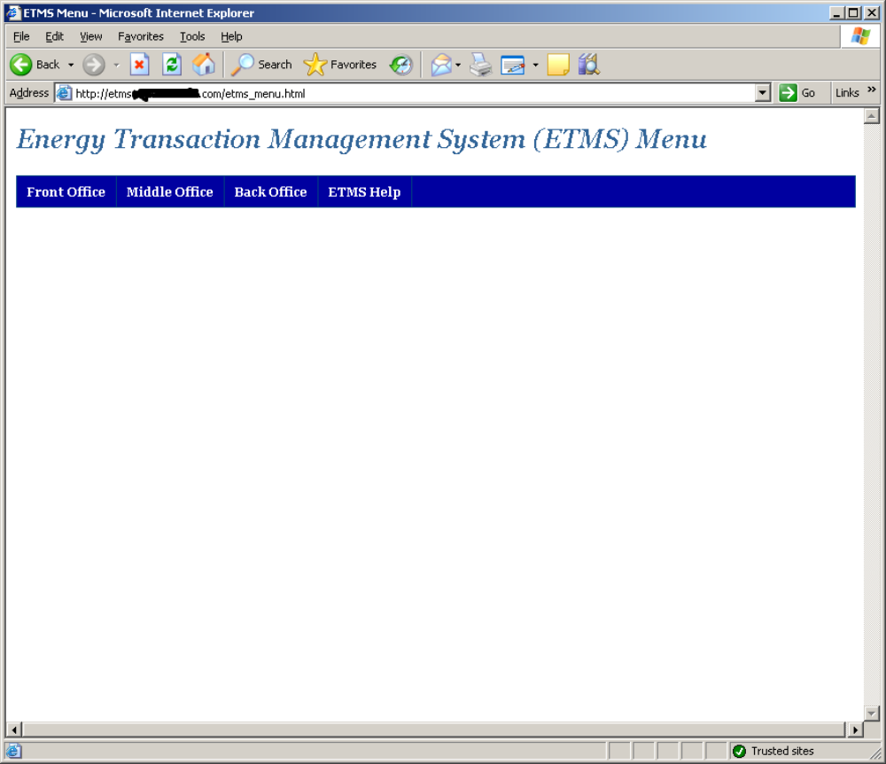

Deal Entry
All ETMS Front Office functionality is accessed from the Deal Entry Screen which has tabbed panes, two for actual deal capture (Deal Entry and Details Tabs) and one reference pane (Broker, Counter Parties and spare tabs), HE schedules Matrix and Power Curves.
After logging in to the system, Traders will be automatically directed to the Deal Entry Screen. Other users can access the screen from the ETMS Main
The following workflow narrative briefly describes how these ETMS Deal Entry screens and other components are used during the deal planning, execution and recording process.

Deal Entry Workflow
The Front Office is the primary interface with the energy marketplace through its marketing and trading interfaces as documented in the ETMS Phase 1 Requirements Specification.
The Trader does the following when planning, executing and recording an energy deal, currently either a gas or electric trade, or an energy option deal:
- The Trader plans the deal by determining the type and amount of energy to either buy, sell or swap; or the type and amount of energy options to either buy, sell or broker (buy and sell in one deal).
As a planning aid, the ETMS Forecasts Pane provides information on energy demand (requirements), net energy supply (resources), and the gap between the two (either positive or negative). See Reference Panes for more information.
- The Trader then works with an approved Broker to negotiate and execute the deal with an approved Counter Party.
The ETMS Parties Pane provides information on fees for all approved Brokers as well as approved Counter Party credit and financial-risk information. See Reference Panes for more information.
- The Trader begins recording the executed trade within the ETMS by first completing the Deal Entry Pane—see Deal Entry Pane & Fields for a screen shot, field descriptions and instructions on completing the pane.
- The Trader then completes the Details Pane—see Details Pane & Fields for a screen shot, field descriptions and instructions on completing the pane.
- Clicking the Submit button on the Details Pane records the deal and finalizes the ETMS deal entry process. Clicking Reset clears all fields on both the Deal Entry Pane and the Details Pane, allowing the Trader to re-enter the deal from scratch.

Deal Entry
Deal Entry is launched by selecting Front Office | Forms Menu

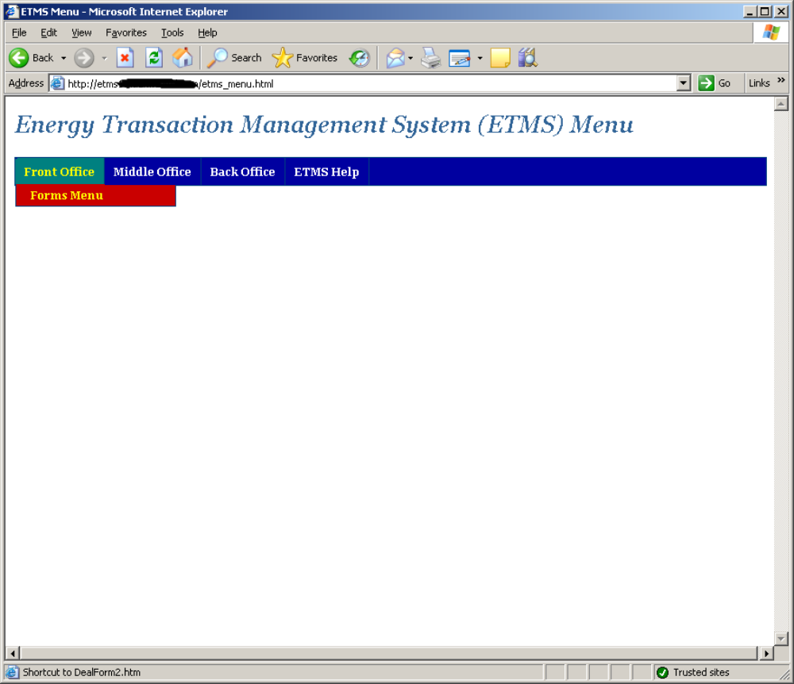

Enter a valid Oracle username and password. Select Oracle instance. Select Form. Optionally select color theme for the form.
Press “Run Form” button.

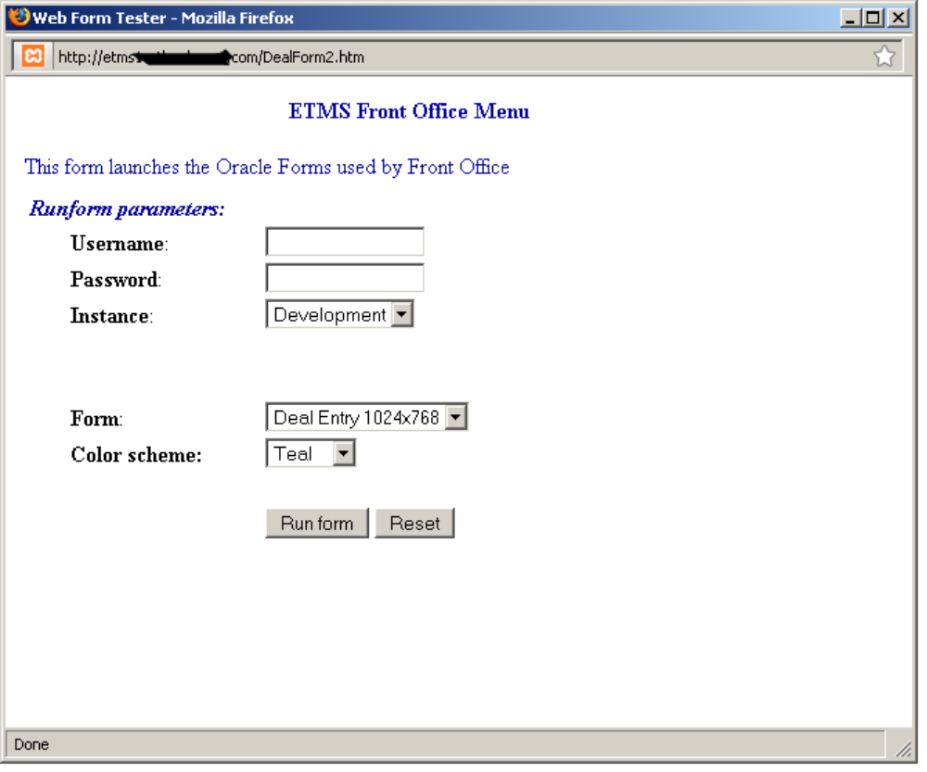

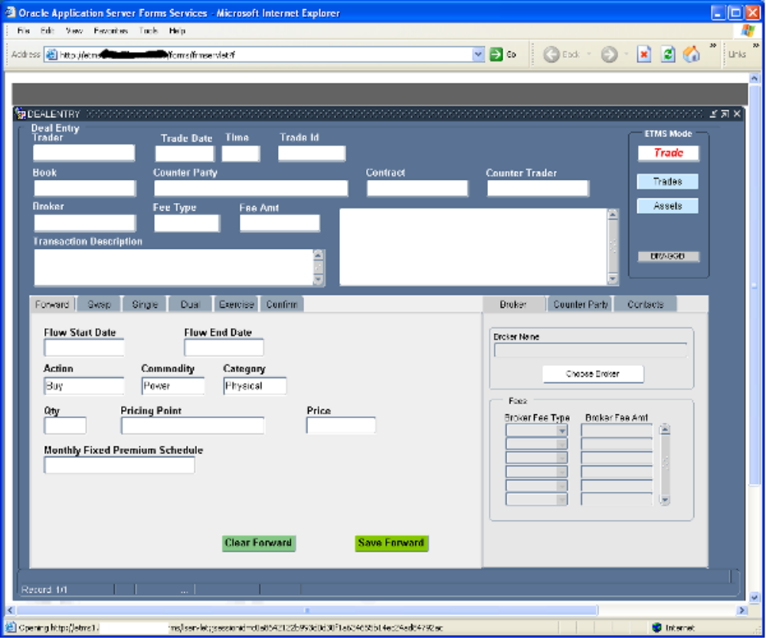

Deal Entry Screen Buttons

In the upper right area of the form there is a frame labeled “ETMS Mode” that encapsulates a two display fields and three buttons.

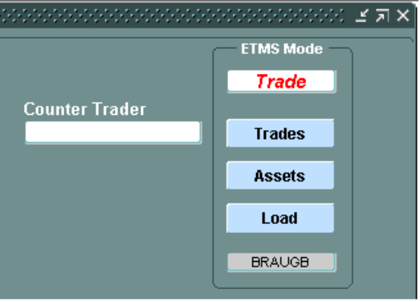
The display field at the top of the frame that has a white background and red text is the deal mode.
This field show the current mode of deal entry. Pressing on of the buttons below will change the mode and cause fields to be visible or hidden based on the business rules associated with the deal mode type.
The grey background display field shows the current logged in user. This information is tagged onto all database activity generated by the transaction.

Reference Panes
Two reference panes are located on the right side of the screen: Parties and Forecasts. The functions of each are described below.

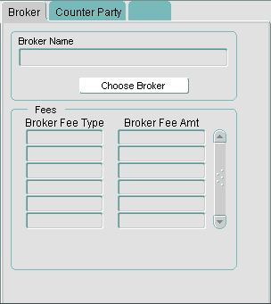

Pressing the “Choose Broker” button pops up the list of Brokers currently in the system.

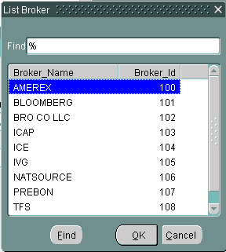

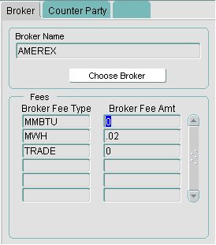

Counter Parties Pane

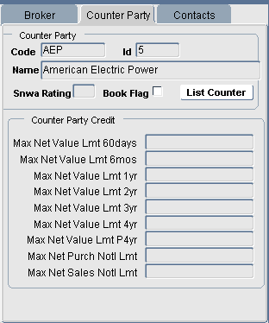
This screen shot displays test data for purposes of example only.

Pane Components

Counter Parties
The Counter Parties tab provides a list of approved Counter Parties, including credit information for each; such as credit positions, the results of risk analysis, dollar limits for commodities the party is qualified to trade, etc. (The exact content of this tab will be finalized during Middle Office analysis.)
Selecting a Counter Party displays their information. Traders can add new Counter Parties from here, from the Deal Entry Pane, and Counter Parties can also be added and edited through the ETMS administrative portal (documented in a future functional design specification that covers ETMS common components)—see Deal Entry Pop-Up Windows for full details.

Brokers
The Brokers tab provides a list of approved brokers, including their fees per energy unit and/or deal.

Selecting a Broker displays their information. Traders can add new Brokers here, from the Deal Entry Pane, and Brokers can also be added and edited through the ETMS administrative portal (documented in a future functional design specification that covers ETMS common components)—see Deal Entry Pop-Up Windows for full details.

Contacts
The Contacts tab provides individual contact information (name, title, organization, phone numbers, e-mail addresses, etc.) for all approved book, counter-party or broker organizations.
Selecting a contact displays their information. Traders can edit existing contact information as well as add new contacts.

This screen shot displays test data for purposes of example only.

Pane Components
For selected periods of time in the future (annual, monthly or daily for each of the books being serviced and at each delivery point), the Forecast Pane’s three tabs do the following: the Demand tab shows energy requirements, the Resources tab shows energy supply as the net of all bought and sold positions, and the Gap tab shows the net supply-versus-demand position against which trades must be made to achieve a balanced energy position.

Deal Entry Pane, Fields & Pop-Up Windows
The Deal Entry Pane and it’s fields are common to all trade types: Forward Trades, Swap Trades and Option Trades (call, put and dual-option).
For the calculations and formulas used by these trade types—the operations performed by the forms (panes and windows) described in this document, see ETMS Calculations (separate document—so be released soon).

Deal Entry Pane
All possible fields are shown below—the actual field combinations displayed depend on the field inputs documented under Deal Entry Fields.

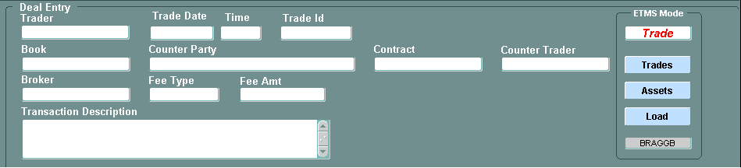

<<< Removed >>>

<<< Removed >>>

Selecting New at Product Shape on the New Pricing Point Window displays a pop-up window that allows users to add new selections to the field’s pull-down menu.
Mandatory fields are boxed in red. All others are optional and have been identified below under Field Descriptions.

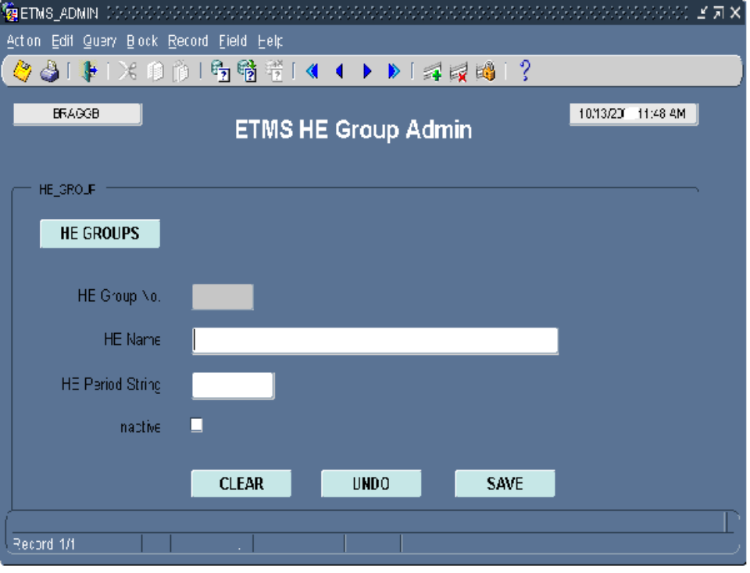

Field Descriptions

HE Template Admin – Power Curve Editor

